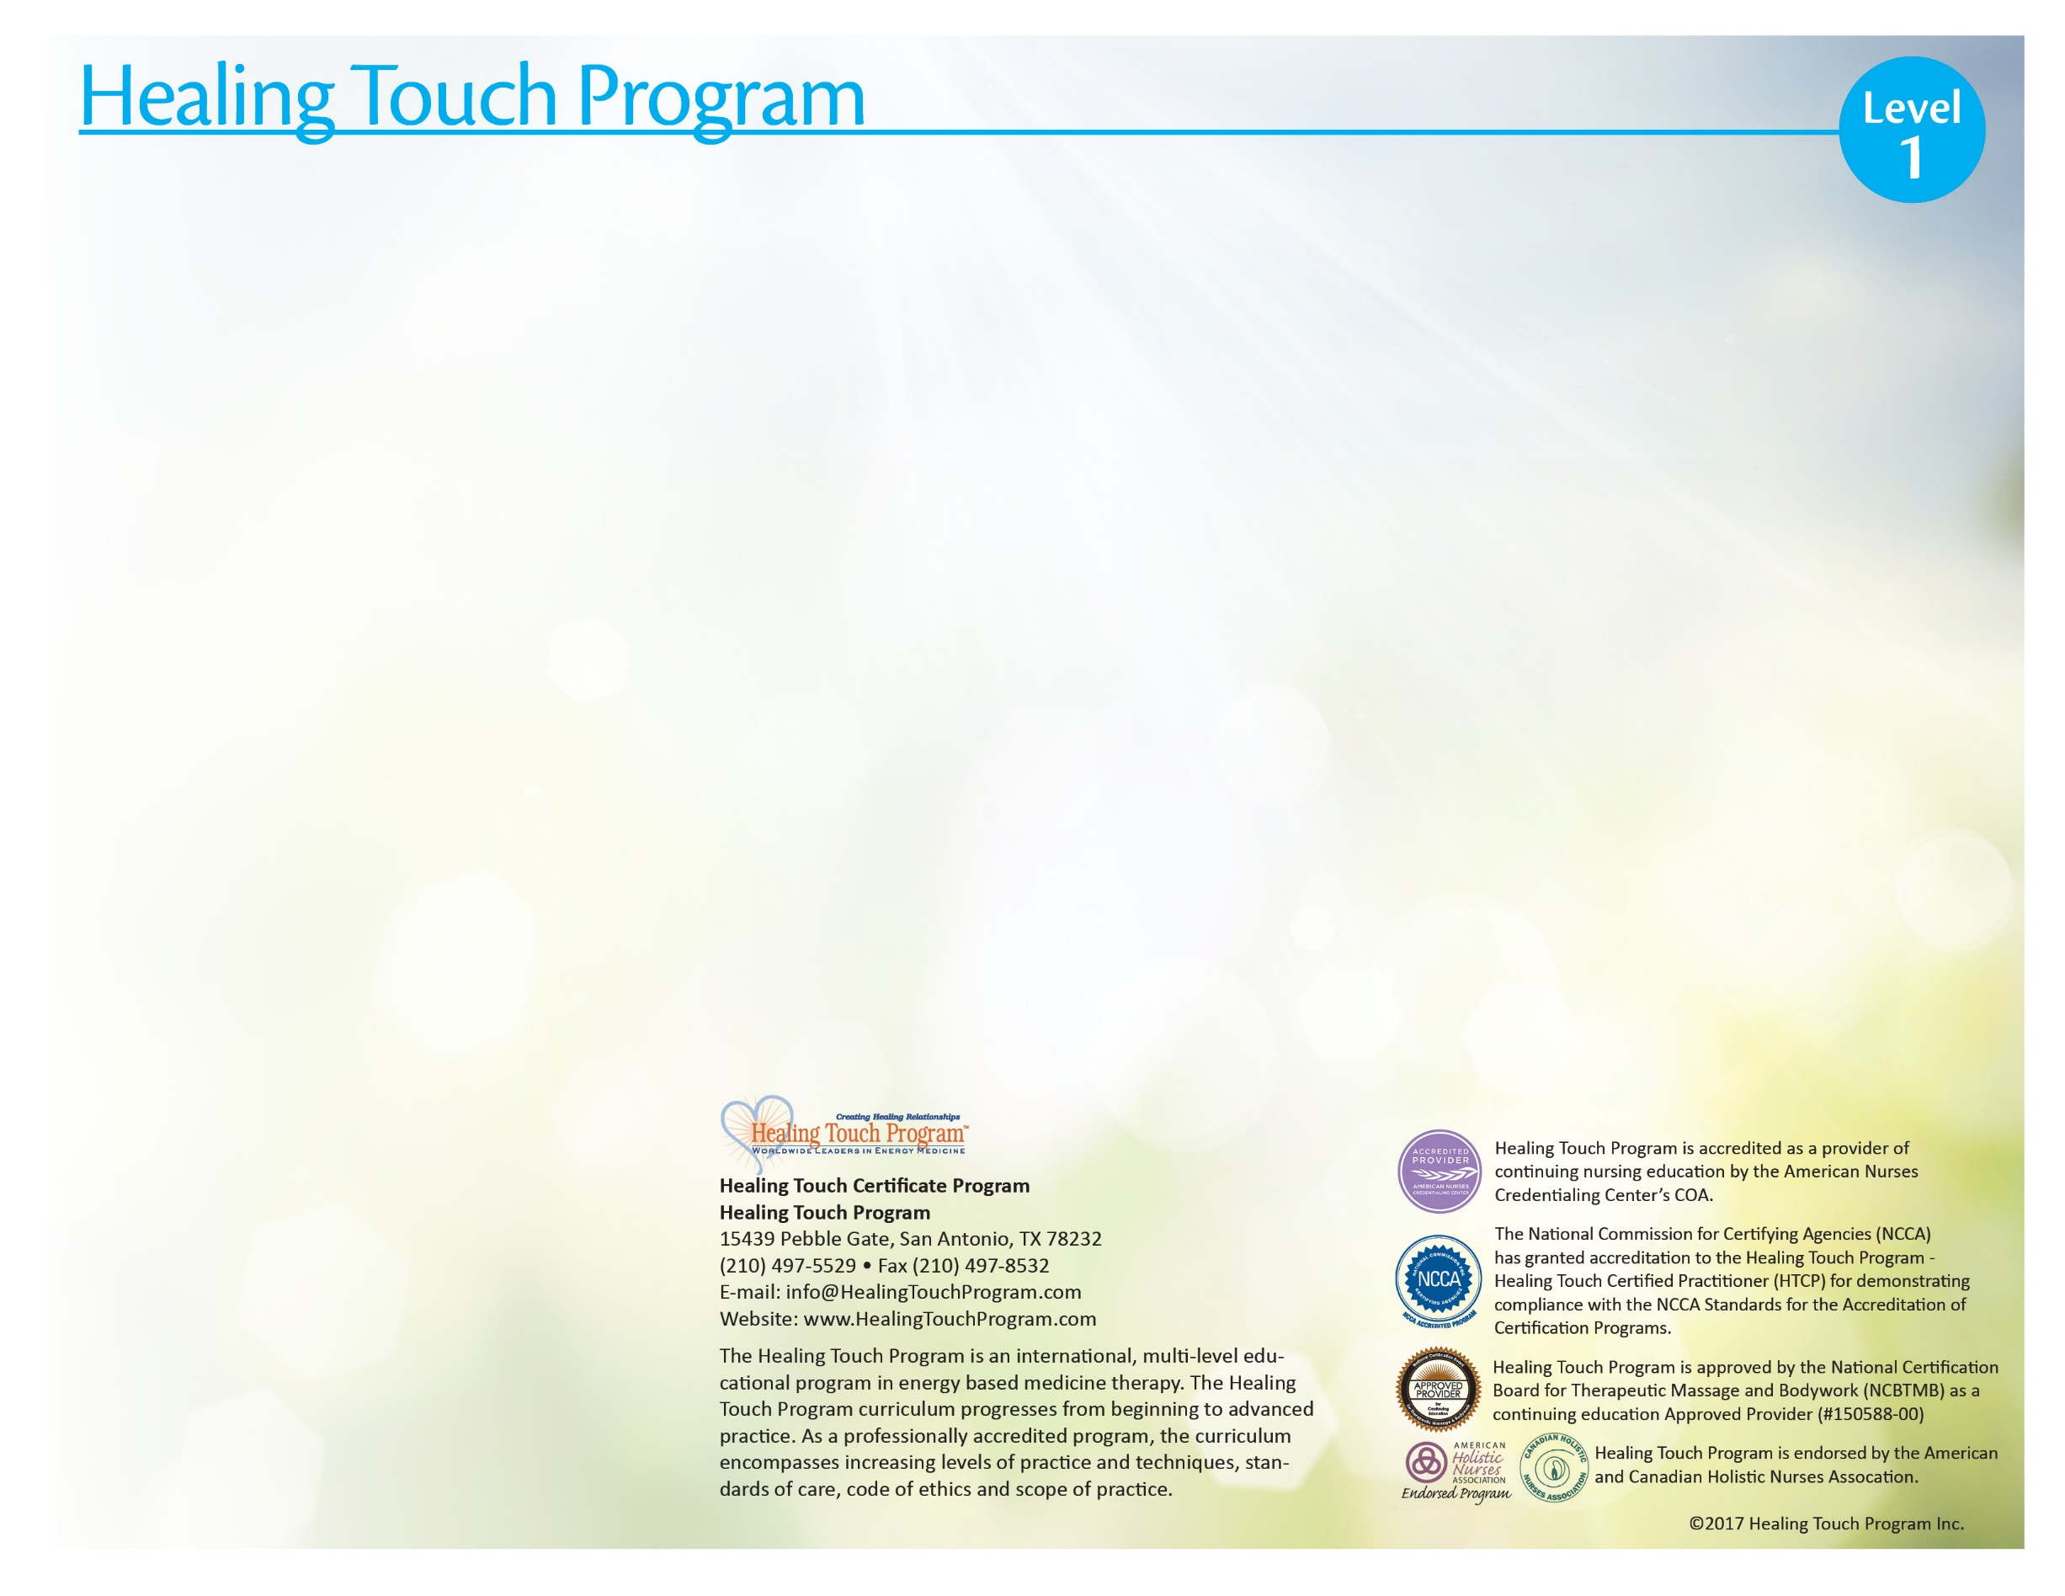
Target Audience
Healing Touch is a nursing based continuing education program for registered nurses, physicians, body therapists, counselors, psycho-therapists, other health professionals, and individuals desiring an in-depth understanding and practice of healing work using energy based concepts.

Healing Touch Program™ Description
A course of study toward a certificate of completion in Healing Touch (HT) which in-corporates a variety of basic to advanced healing modalities. The program is sequenced in 6 levels allowing participants to move from beginner to advanced practitioner, expert and instructor. Certification as a Healing Touch Practitioner and Instructor is available on application following completion of course work and additional requirements.

Level I Description
Level 1 begins with 16-18 continuing education contact hours of instruction, allowing persons with varying backgrounds to enter, acknowledge their previous learning and to further develop concepts and skills in energy-based therapy. A strong commitment to personal growth is required.

The participant will learn how to:
- Describe the human energy system relationship to physical, emotional, mental and spiritual health.
- Discuss energy principles basic to HT.
- Assess the energy field and energy centers.
- Identify a basic Healing Touch sequence.
- Demonstrate specific intervention techniques used in Healing Touch.
- Discuss applications of Healing Touch in personal and professional practice

Level I Course Content
- Energy system concepts related to health
- Basics of the energy system, energy field and energy centers
- Location and function of the chakras
- Assessment of the energy field and energy centers
- Meditation for centering and maintaining energetic flow
- Principles and practice of Healing Touch
- Selected intervention techniques: Basic Healing Touch Sequence, Magnetic Passes, Magnetic Clearing, Chakra Connection (1 on 1, 2 on 1, self), Headache Techniques (tension, migraine, sinus), Ultra Sound, Laser, Chakra Spread, Scudder (Optional), Mind Clearing (Optional)
- Principles of self-healing
- Personal development as a healer
- Legal and professional aspects of touch therapies

16 Continuing Education Contact Hours

Workshop Information

Schedule: August 18th – 19th, 2018

Location: South Charlotte, NC

Coordinator: Marilyn Stulb

Instructor: Marilyn Stulb, MATP, HTCP/I, CCA
Marilyn’s passion is Healing Touch specializing in assisting clients with trauma.
She is a 39 year flight attendant and member of the American Airlines CIRT team assisting crew members with trauma while on duty. She has presented Healing Touch and transpersonal practices to American Airlines members in Dallas.
Marilyn has a private practice in Charlotte, NC of Healing Touch, Sound Therapy, Aromatherapy, and Transpersonal Psychology. These therapies have proven successful in treating trauma.
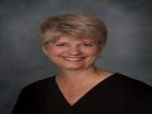

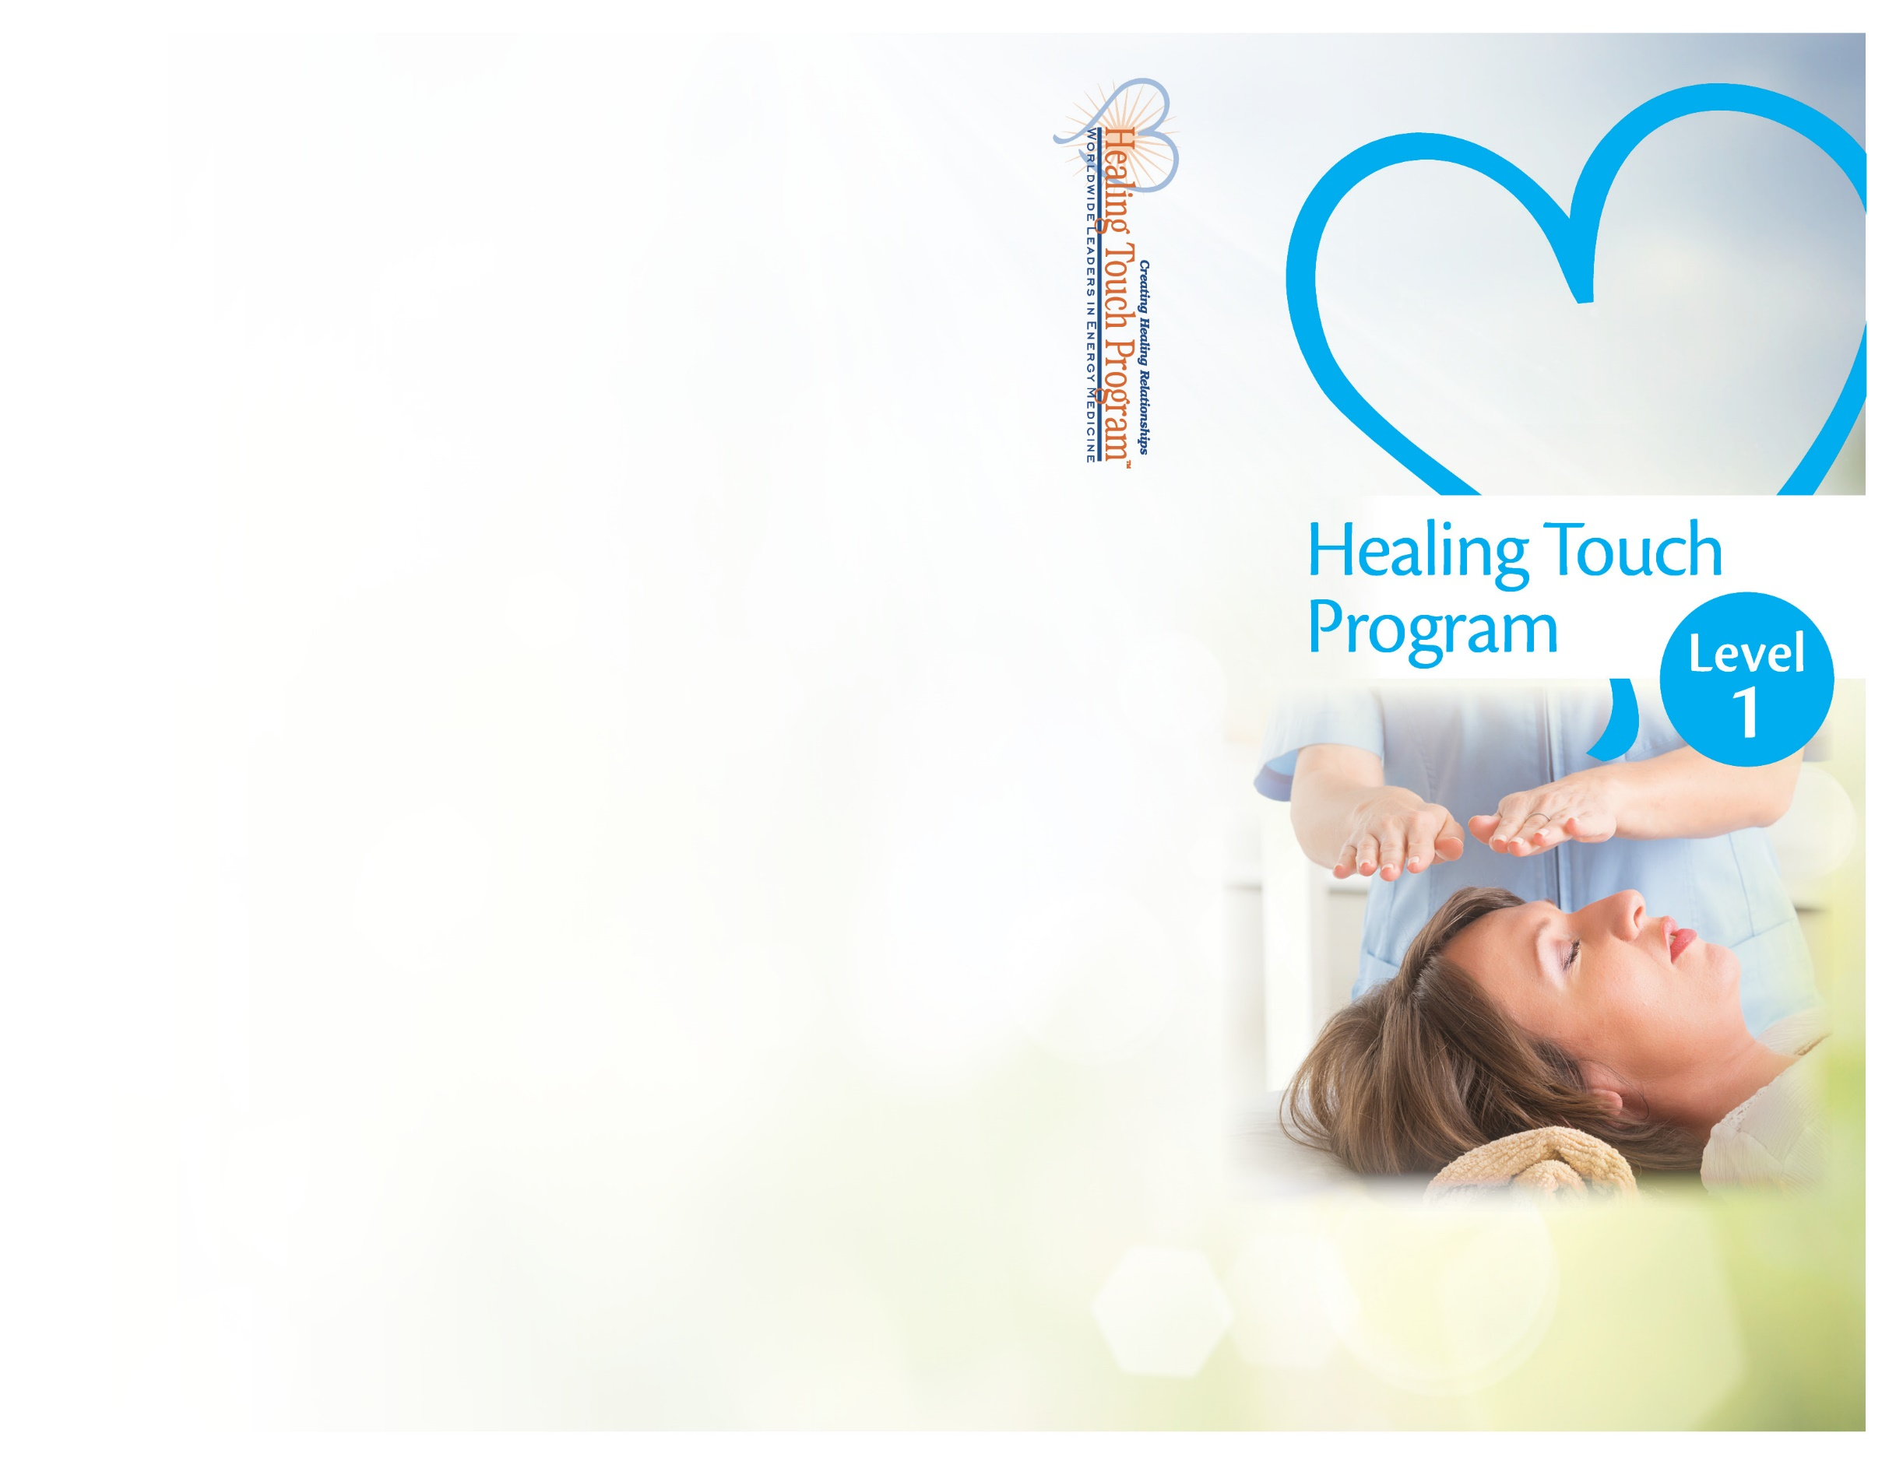
South Charlotte, NC
Registration Form
Healing Touch Level 1
August 18th – 19th, 2018

Name: ____________________________________
Address: __________________________________
City: ______________________________________
State: __________________ Zip: ______________
Home Phone: ______________________________
Work Phone: ______________________________
E-Mail: __________________________________

Please check one of the following:
- Regular Tuition - $497
- HTPA or AHNA Member Tuition - $447
- Full-time Student - $297
- Repeat - $247

$ Amount Enclosed (min. deposit $100)

Register Early!
Enrollment Limited!

Can you bring a massage table? __ Yes __ No

Make checks payable to: Marilyn Stulb
Send to: Marilyn Stulb
7530 Bluestar Lane
Charlotte, NC 28226

MH Stulb
7530 Bluestar Lane
Charlotte, NC 28226

Charlotte, NC
August 18 -19, 2018

